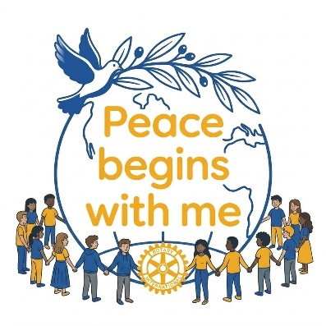

Rotary District 5330 Art for Peace Program
Contest Rules & Entry Form
This Year’s Theme: Peace Begins With Me
Entry Details and Rules
- Through your art, show the judges how you create, support or imagine a peaceful local or global community.
- All entries must incorporate a Rotary International or Rotary Interact logo clearly visible within the artwork.
- Art must be no larger than 11” X 14”.
- Art canvas/board thickness may not exceed 1/2 inch.
- Media Choices: Oil, pastel, crayon, pencil, pen and ink, watercolor, markers, graphic design, multimedia, collage or photography.
- Students may submit only one entry.
- Students may not place their names on the front of the artwork.
- Students agree to allow the artwork to be published in Rotary International social and print media.
- Entries created using artificial intelligence (AI) either partially or completely may not be entered into the contest,
- Students may only enter one Rotary Club’s contest in a calendar year.
- Every attempt will be made to return the artwork to the student.
Age Group Categories
- Grades TK-2; Grades 3-5; Grades 6-8; Grades 9-12

Club Level Contests
- Individual Rotary Clubs will hold their Art Contests from October 15, 2026 to November 15, 2026. It is recommended that Clubs present First, Second and Third place awards to students. Monetary awards are not required and they at the discretion of the individual Clubs. Some clubs have presented art kits to their club winners.
District Level Contest
- Each Rotary Club may submit their First-Place entry in each category to the Rotary District 5330 Art for Peace Contest. The deadline to submit the entries to the District Contest is November 24, 2026. Deliver or mail entries to the contest chair: Linda White, 9123 Deergrass Street, Corona, CA 92883 (cell # 951-532-7310; lindawhite346@yahoo.com). The District-level judging will take place on Saturday, December 12, 2026 in Corona, CA at a location to be determined. The judging will not be open to the public. Artwork will be returned to the student following the judging.
- Winners will be announced Monday, December 14, 2026 at 4:00 PM on the Rotary District 5330 Website.

Prize Awards
Grades TK-2: First Place $250 Second Place $150 Third Place $100
Grades 3-5 First Place $250 Second Place $150 Third Place $100
Grades 6-8 First Place $250 Second Place $150 Third Place $100
Grades 9-12 First Place $250 Second Place $150 Third Place $100

Winners and their parents/guardians will be invited to attend the 36th Annual Garbis Der-Yeghian Peace Conference on January 23, 2027 at Cal Poly Pomona in the Kellog Center. The student artwork will be displayed at the Peace Conference, and each winner’s check will be presented at the Peace Conference to the student or the Rotary Club representative. Winners and their parents/guardians will also be invited to the District 5330 Rotary Youth Showcase Event in April 2027.

Continued
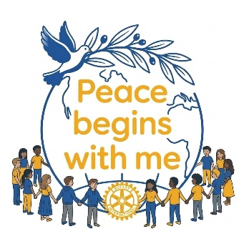

Rotary District 5330 Art for Peace Program
Contestant Entry Form
PRINT AND FIRMLY ATTACH THIS ENTRY FORM TO THE BACK OF YOUR PROJECT

___________________________________________________________________________
PRINT First and Last Name PRINT Title of Art Piece

___________________________________________________________________________
Grade School of Attendance

___________________________________________________________________________
Parent/Guardian Name and Address City State Zip Code

___________________________________________________________________________
Parent/Guardian Email Contact phone number with Area Code

___________________________________________________________________________
Name of Sponsoring Rotary Club

___________________________________________________________________________
Name of Sponsoring Rotary Club’s Art for Peace Contest Chair and Email

Who would you like to thank for inspiring you to enter the contest and why?
___________________________________________________________________________
___________________________________________________________________________
___________________________________________________________________________
I give permission for images of this artwork to be circulated throughout Rotary Publications, print media, and public domain social platforms. (Parent/Guardian signature is required if the contestant is under the age of 18.)
___________________________________________________________________________
Parent/Guardian signature Date

