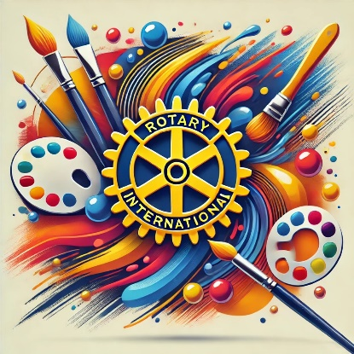
Rotary Art for Peace Program-Club Level Chair Responsibilities
- Thank you for volunteering to Chair your club’s Art for Peace Scholarship Contest.
- Notify the District Chair Linda White) by email( lindawhite346@yahoo.com) by September 30, 2026, that your Rotary Club is interested in participating in this new Art for Peace Scholarship Program. By doing so, you will receive additional training via Zoom on how to conduct your club’s contest.
- Recruit members of your club and interested community members to be part of your Art for Peace Scholarship committee. Local art teachers, school district art specialists, and local art societies may be good sources for committee members
- Have your committee review the contents of the Contest Rules and Entry Form. Make copies of information that you want to distribute. Pay close attention to the Important Dates listed in the rules.
- Decide which age-groups you would like to focus on this year. You may focus on all four age groups, but you don’t have to.
- It is recommended that clubs use the District 5330 judging rubric. This will be the judging rubric used at the District Contest. Be sure the participants have been given copies of these documents so they can use the forms when creating their artwork.
- Contact the public, charter and private schools in your area and let them know about your club’s Art for Peace Scholarship program. Identify a cooperating teacher(s) and contact them. Volunteer to go to the school(s) and explains all about the Art for Peace Program, why we have it, how the artwork will be are judged, and what the prize money will be if a contestant places in the top three spots in the district level contest.
- Follow all school and Rotary youth protection guidelines regarding child safety.
- Set your date/time/location for your Club contest. All club-level contests should be held October 15-November 15, 2026.
- Students may only submit one entry per contest.
- It is recommended that Clubs present Award certificates to the first, second and third place finishers and participation certificates to all contestants. Monetary awards are not required or encouraged at the club level. Some clubs have presented art kits to winners.
- Each Rotary Club may submit their First-Place entry in each category to the Rotary District 5330 Art for Peace Scholarship Contest.
- The deadline to submit the entries to the District Contest is November 24, 2026. Deliver or mail entries to Linda White, 9123 Deergrass Street, Corona, CA 92883.
- There is no fee to send a contestant’s entry to the District-Level Contest.
- The District-level judging will take place on Saturday, December 12, 2026 in Corona, CA at a location to be determined. The judging will not be open to the public.
- Winners will be announced on Monday, December 14, 2026 on the Rotary District 5330 website at 4:00 PM.
- Winners and their parents/guardians will be invited to attend the Annual Garbis Der-Yeghian Peace Conference on January 23, 2027 at Cal Poly Pomona in the Kellog Center. The student artwork will be displayed at the Peace Conference. In addition, the artwork will be displayed at the Rotary District 5330 Youth Showcase in April 2027.
- District level Prize Amounts:
Grades TK-2 First Place $250 Second Place $150 Third Place $100
Grades 3-5 First Place $250 Second Place $150 Third Place $100
Grades 6-8 First Place $250 Second Place $150 Third Place $100
Grades 9-12 First Place $250 Second Place $150 Third Place $100
- Each winner’s check will be presented at the Peace Conference to the student or the Rotary Club representative.
- Every attempt will be made to return the artwork to the students.

Please make sure that all contestants are aware of the contest rules.

